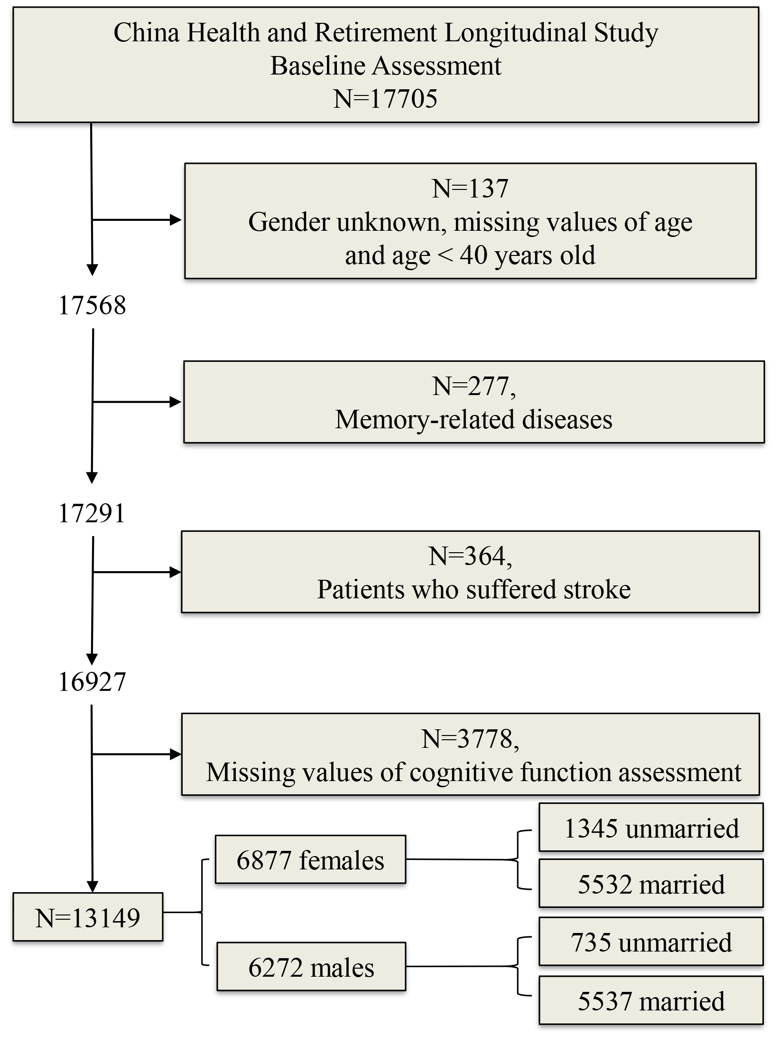
Supplemental Fig. 1. Flowchart of data cleansing.

